Case Study Methodology for Islamic Studies Researchers
A Comprehensive Overview of Its Types, Elements, and Implementation
*Muhammad Nabeel Musharraf
**Dr. Basheer Ahmed Dars
***Dr. Hadi Bux Chhijan

ABSTRACT:
Case study methodology is very effective for the situations where acquiring deep insights about the cases under study within their specific contexts is the objective. This methodology is widely applied in a range of disciplines and enjoys a highly prominent status in Islamic studies, educational, and social sciences research among many other disciplines that utilize this approach. This literature review paper provides useful guidelines for researchers who wish to gain a deeper understanding of this methodology with regards to situations when it can be applied, the recommended protocol to implement it, the procedural recommendations that are required to be adhered to and how the findings from case study research can augment the existing knowledge or create new theories. In compiling this paper, we have not only referred to the works of the renowned case-study methodologists such as Yin, Stake, Merriam, Eisenhardt etc. (like most researchers who have done the literature reviews on case study methodology) but also referred to the research and analysis from other researchers who have focussed on application, review or critique of their works; this approach provides unique insights about this methodology. In this paper, we have provided a synthesis of literature on various perspectives about the definition of the case study methodology, its various types depending on the research purpose and research design, the application protocol, and other key elements and methods that come under the umbrella of case study research. This literature review paper can be a useful induction for the Islamic studies and social sciences researchers to this important research methodology.
The case study methodology, like other methodologies, has not just received the praise; mit has also received criticism from some researchers. An overview of the key concerns raised in this regard, such as lack of rigour, lack of generalizability etc. and how the case study researchers have responded to it has also been woven into the article. We have found that most of the criticism is either because of a lack of thorough understanding of the case study methodology, or because of its incorrect application. In addition, it is partly due to the fact that the case study methodology has evolved over time and it is not the same now as it used to be a few decades ago. Considering a number of perspectives where recommendations from the case study researchers converge and diverge, this paper provides a valuable synthesis of literature for the Islamic studies researchers aiming to adopt case study methodology in their research.

KEYWORDS: Case Study, Methodology, Generalization, theory

……………………………………………………………………………..
*President, Islamic Circle of Australia and New Zealand, Australia
**Faculty member, MUET, SZAB Campus khairpur Mir’s, Sindh, Pakistan
***Assistant Professor, MUET, SZAB Campus Khairpur Mir’s
- INTRODUCTION
Islamic studies researchers often focus their research on certain personalities, books, phenomena, events, places, and other aspects or entities which can be classified as ‘cases’ under the case study research methodology. However, the review of literature suggests that a lot of Islamic studies and social sciences researchers are not fully conversant with the case study methodology. It is pointed out by research that a proper understanding and application of this methodology can significantly enhance the impact of research. We have, therefore, written this important literature review paper to serve as a guide for the Islamic studies researchers in terms of the methodological description and phases of case study research methodology.
Before we begin our discussion, it is important to note that the case study methodology has been criticized by many researchers who blame that this research approach lacks rigour, methodological orthodoxy, and adequate planning (Fidel, 1984; R. Miles, 2015). Some even refer to it as the “weak sibling” (Yin, 2003). What is the whole point of writing this paper then? The answer to this question lies in the fact that a large number of researchers have questioned this criticism, identified its shortcomings, and provided an adequate response to it (Yin, 2013; Crowe et al., 2011; Flyvbjerg, 2006; Gerring, 2004; R. Miles, 2015; Ruddin, 2006; Runeson & Höst, 2009; Thomas, 2010) suggesting that the criticism shows the over-simplified assumptions about case study as a methodology. Supporting their arguments is the wide application of case study methodology in situations where detailed insights are required about certain objects, situations, phenomena or processes being studied in their natural real-life context. These insights can often not be covered by other approaches due to a high number of factors and variables involved (Rowley, 2002, Crowe et al., 2011). Due to this feature, case study research is also referred to as the ‘catch-all’ design as it adds further weight to traditional frameworks (Merriam, 2009).
The roots of development of ‘case study’ go to the social sciences, but nowadays, there is hardly any research discipline in which it is not applied extensively (Labaree, 2016; Meyer, 2001; Rowley, 2002, Johansson, 2003; Feagin, Orum, & Sjoberg, 1991; Runeson & Höst, 2009; Fidel, 1984, Willig, 2013, Simons, 2009). Especially, in educational research, it has been the most prominent approach among the contemporary researchers (Yin, 2006, R. Miles, 2015; Pereira & Vallance, 2006; Yazan, 2015). Considering the above, it is believed that the Islamic studies researchers can also hugely benefit from this approach.
Reviewing the history of case studies suggests that this methodology has evolved over time (Johansson, 2003; Willig, 2008). Various key researchers have contributed to the development and growth of case study as a research methodology. Its recent and the most refined form is an outcome of works from researchers like Yin, Stake and Merriam whose guidelines and suggestions have become foundation stones for the case study research in present times (Brown, 2008; Yazan, 2015). In various aspects and dimensions of case study methodology, there are areas where their perspectives and approaches diverge, converge and complement one another (Yazan, 2015). Building on the proposed approaches from these key researchers, there are many others who have either based their works on them or augmented them to suit their requirements (Yazan, 2015).
This literature review presents a synthesis of literature on various methodological aspects, methods, types and elements of case studies research while referring to a wide range of relevant literature.
- SCOPE OF LITERATURE REVIEW:
The focus of current case study literature review includes the explanation of case study research method and its applicability, methodological aspects of case study research and its relationship with other methodologies, an overview of method selection process for application in case study research, key elements of case study research design and the quality assurance aspects as shown in figure 1.
- WHAT IS THE ‘CASE STUDY METHODOLOGY’?
Different researchers have defined this methodology differently (Johansson, 2003; Zucker, 2009) with basic principles remaining the same.
Following is a compilation of definitions by various researchers:
Most renowned definition is the one provided by Yin:
“A case study is an empirical inquiry that investigates a contemporary phenomenon within its real-life context, especially when the boundaries between phenomenon and context are not clearly evident”. (Yin, 1994, p. 13)
According to Stake, “Case study research is an investigation and analysis of a single or collective case, intended to capture the complexity of the object of study” (Stake, 1995)
Thomas (2011) has provided a very comprehensive definition:
“Case studies are analyses of persons, events, decisions, periods, projects, policies, institutions, or other systems that are studied holistically by one or more method. The case that is the subject of the inquiry will be an instance of a class of phenomena that provides an analytical frame — an object — within which the study is conducted and which the case illuminates and explicates”. (p.23)
“A case study research paper examines a person, place, event, phenomenon, or other type of subject of analysis in order to extrapolate key themes and results that help predict future trends, illuminate previously hidden issues that can be applied to practice, and/or provide a means for understanding an important research problem with greater clarity” (Labaree, 2016).
Case studies can follow qualitative, quantitative or both of these approaches (Yin, 2012; Hoffmann, 2008) as explained later in this paper. Merriam was more inclined towards the qualitative approach. According to her definition, the qualitative case study is “an intensive, holistic description and analysis of a bounded phenomenon such as a program, an institution, a person, a process, or a social unit” (p. xiii).(Merriam, 1998)
“Case studies are in-depth investigations of a single person, group, event or community. Typically, data are gathered from a variety of sources and by using several different methods (e.g. observations & interviews). The research may also continue for an extended period of time, so processes and developments can be studied as they happen”. (McLeod, 2008) (Runeson & Höst, 2009)
According to Baxter and Jack (2008), the case study is a methodology which studies ‘how’ and ‘why’ questions in situations in which researchers cannot manipulate the behaviour of those involved in the study and contextual conditions are required to be covered because the researcher considers them relevant to the problem while the boundaries are not clear between the phenomenon and context.

Figure 1: Scope of Literature Review

- “Systematic inquiry into an event or a set of related events which aims to describe and explain the phenomenon of interest” (Bromley, 1990)
- Case study methodology is the study and examination of real life situations which require the detailed and in-depth observation of the cases which can be an event, process or person (Feagin et al., 1991).
Based on above definitions, we can synthesize the following definition:
Case study is a systematic and empirical inquiry that is conducted by an in-depth and intensive analysis, holistic description and/or investigation of persons, groups, events, community, decisions, periods, projects, program, policies, institutions, systems, social units or phenomenon of interest (known ‘cases’ under this methodology) under their real-life context in which research is not able to manipulate any factors or behaviours. This methodology involves data collection through various methods (which can be qualitative, quantitative or both) over a period of time. The outcome of this study is the extrapolation of key themes and results, prediction of future trends, illumination and explication of previously hidden issues and a better understanding of research problems.
It is considered important to clarify the term ‘empirical inquiry’ used by Yin in his definition. It should not be appropriate to assume that Yin meant case studies to be ‘quantitative’ in nature by mentioning them as an empirical inquiry as considered by some researchers (Margolis & Pauwels, 2011). The use of the word ‘empirical’ to highlight the need for being systematic and gathering data from relevant sources (using qualitative, quantitative or mixed methods) in an appropriate manner. We have explained the use of qualitative and quantitative methods in a later section in this paper.
- WHEN CAN THE CASE STUDY METHODOLOGY BE APPLIED?
Some researchers have argued that the case study methodology is useful in situations where the phenomena or the case is fully mature and understood with constructs already identified (Darke, Shanks, & Broadbent, 1998). However, Dobson (1999) explains that this point of view does not give reasonable consideration to the variety of ways in which case study can be conducted to bring in light the new and alternate perspectives about the cases from same or different ontological or theoretical perspectives. Similarly, another group of researcher believes that case studies are useful only in the exploratory phase and cannot be used in other situations e.g. when a hypothesis is formed and it is required to be tested (Yin, 2011). Yin (2011) has questioned this viewpoint and explained a number of other ways in which case study research can be used.
The case study methodology is most applicable when the “how” and “why” questions are being answered through detailed analysis and investigation (Yin, 2006, 2009, 2011, 2013; Baxter & Jack, 2008; Meyer, 2001; Zucker, 2009; Skogerbø, 2011; Rowley, 2002; Yazan, 2015). However, case study methodology can also be applied in other situations as explained below.
Yin (2006, 2013) frames the two types of situations when case study can be effectively applied. The first situation is when a descriptive question is being answered e.g. ‘what happened’ or ‘what is the structure of a particular degree program’. This also includes the explanatory questions involving ‘how’ and ‘why’. The second situation involves those research problems which require illumination of a particular situation through in-depth analysis and acquisition of first-hand information. In such situations, deploying case study methodology assists researchers in making a direct observation and collect data under natural settings. This means that the analysis and findings are not dependent on the “derived” data. These two situations and relevant questions in them determine if the case study design will be explanatory, exploratory or descriptive (Rowley, 2002). These, and other, types of case study designs are explained later on in this paper.
Other methodologies are more appropriate when the effectiveness of a particular intervention or initiative is being gauged against certain outcomes (suitable method for this situation might include experimentation or quasi-experiments) or assessing how often a situation happens or a particular condition exists (suitable method for this situation could be a survey) (Yin, 2011) . Yin (2011) explains that these other methods are not expected to provide the in-depth explanations and insights which case study methodology can bring to light. The in-depth analysis and interpretation obtained through case studies results in specific recommendations or actions for improving present conditions (Labaree, 2016).
The three considerations shown the Table 1 (i.e. types of research questions, requirements related to behavioural control and need for focus on contemporary or historical events) determine the methodology selection as explained by Yin (2009) and other researchers (Rowley, 2002; Yin, 2011).
Yin (2009, 2011) has summarized his recommendations in this regard as follows (p. 8).
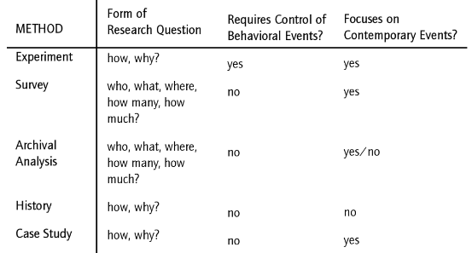
Table 1: Relevant situations for various research methodologies as shown by Yin (2009)
Case studies, as shown in table 1, focus on ‘how’ and ‘why’ questions related to contemporary events or phenomena and do not require behavioural control (Skogerbø, 2011). Though ‘what’ questions are not presented in the table above, in the discussion preceding this table in chapter 1 of Case Study Research: Design and Methods, 5th Edition, Yin also discusses the possible situations where the ‘what’ questions can also be answered through case study research (Yin, 2013).
- RELATIONSHIP BETWEEN METHODOLOGIES:
A major distinguishing aspect of the case study is that it uses different methodologies in combination with each other to obtain detailed insights about the case(s) at hand to triangulate and illuminate them. (Johansson, 2003; R. Miles, 2015; Skogerbø, 2011).
Hyett, Kenny and Virginia Dickson-Swift, (2014) have highlighted the opinion of various researchers who consider the case study as ‘a stand-alone qualitative approach’ which offers an extent of flexibility and cannot generally be practiced under other qualitative approaches. Some other researchers consider it different from ethnographic and other ‘strictly qualitative research paradigms’ arguing that it can deploy any mix of quantitative and qualitative approaches(Klein & Myers, 1999; Rowley, 2002, Willig, 2013). Another group of researchers considers it as a combination of various methodologies (Groat & Wang, 2013). What exactly is a relationship (or a lack of relationship) of the case study with other methodologies? In an attempt to delineate this, we have found following two graphical representations to be very relevant and interesting:
  - Demonstration of relationship between research methodologies by Groat and Wang (2013, p. 15):
This graphical representation from Groat and Wang (figure 2) was presented from the point of view of ‘action/ applied’ research as well as ‘theory’ development. Hence, the vertical dimension in the figure relates to the desired outcome of the research project. The methodologies which are next to each other on the disc have some aspects of methodology in common (description of these commonalities is available in chapter 1 of the 2nd edition of their book: Architectural Research Methods).
Groat and Wang (2013, p. 15) placed the case study methodology at the centre of their disc of methodologies showing the ‘combinational’ aspect this methodology deploys and is accordingly referred to as the ‘meta-method’ (Johansson, 2003).This central position is not for the purpose of arguing that the case study is more important than other methodologies but from the perspective of its combinational nature which makes it highly suitable for cases which need an in-depth study (Johansson, 2003). We accordingly understand from this that the case study methodology shares the methodological approach with various other methodologies in a unique manner.
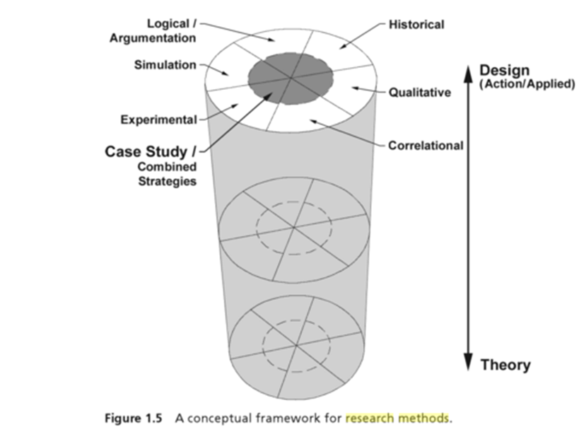
Figure 2: Relationship between methodologies (Groat & Wang 2013)
  - Demonstration of relationship between research methodologies by Johansson (2003):
Johansson explains various research situations and the research methodologies suitable for those situations as follows:
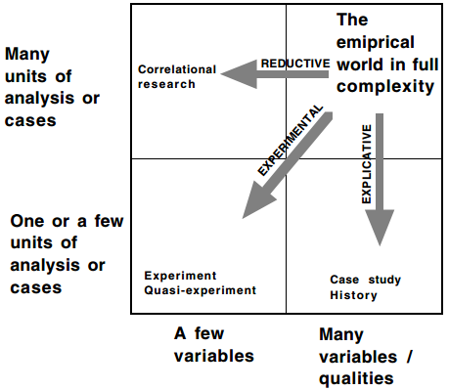
Figure 3: Methodology Suitability criteria graphically represented by Johansson (2003)
In relation to this graphical representation, Johansson explained that in order to reduce the complexities in the study to a manageable level, three strategies are deployed.
- Reduction in units of analysis (explicative approach)
- Reduction in variables or qualities to be studied (reductive approach)
- Reduction in both (experimental approach)
We see from above that case study methodology is a form of explicative strategy. It is due to this approach that case studies facilitate analysis and investigation of the case or cases under study to a level of detail which is not possible if a large number of cases or research participants are examined (Yin, 2011) with the aim of ‘averaging’ (McLeod, 2008). Accordingly, through the case study methodology, we can study, explore and analyse various aspects related to cases, understand the relationships between them, view the process within its total real-world context and also use the researchers’ capacity for empathic understanding of human behaviour(Meyer, 2001).
The study of cases within their real-world context warrants the collection of data in non-manipulated natural settings and restricts or eliminates the dependence on derived data (Bromley, 1986, p. 23)—for example, observing the cases, conducting interviews etc. (Yin, 2011).
  - Case Study – A method or methodology?
Some researchers consider case study methodology to be ‘betwixt and between’ the methods and methodology (Miles, 2015). Following are relevant definitions of these concepts which clarify the difference between the two.
Marelli (2014) explained that methodology “refers to the strategy, the plan, and action, the process or design lying behind the choice and use of a particular method”. Cavaye (1996, p.227) explained that research methodology or strategy is defined as “a way of going about one’s research, embodying a particular style and employing different methods”. This definition is consistent with the definition provided by Somekh and Lewin (2005, p. 346) who defined methodology as "the collection of methods or rules by which a particular piece of research is undertaken" and the "principles, theories and values that underpin a particular approach to research".
Thiel (2014) explained that research methods are means of gathering data in the research and that given a strategy, various different methods can be employed to gather required data.
From this description, we see that case study is more of a methodology than a method.
At this point, it is important to clarify the difference between ‘case study’ as a research methodology and ‘case report’ method. These two concepts are distinctively different from each other (Hymel, 2005). The term case report, often used in clinical and medical professions (Berent & Albers, 2012; Frantz, 2009; Hymel, 2005), refers to descriptions of clinical practice (Hymel, 2005) or the “reports on the treatment of individual patients or a report on a single patient” (Isenburg, 2016). In order to identify the recent use of ‘case reports’ in various disciplines, a search was conducted on articles from Curtin University library catalogue for the keyword “case report” during the year 2015. The search came up with 24693 case reports. During the random review of search results as well as sorting/ filtering through various mechanisms did not come up with any articles that did not belong to medical or a closely related profession. It is therefore possible that the ‘case report’ is more predominantly used in medical profession though its implementation in other fields (such as psychology, social work etc.) is also known (Blaikie, 2009).
Case reports that deal with up to three cases do not qualify to be classified as research (“Case Report Publication Guidance,” 2006, “Case Reports - Health Sciences Campus Institutional Review Board,” 2016), however, beyond three cases, it is considered to be a ‘case series’.
From above discussion on case report method, it is evident that it very different from case study methodology. An important discussion in section 7.1.3 focuses on the ‘descriptive’ type of case study which deploys various methods to describe a situation through case study research methodology which can be considered closer to case report method but not the same considering the relevant methodological aspects attached to it.
Another important finding in this regard is highlighted by Hyett et al. (2014) who identified through their meta-analysis of case studies that a third of research works they analysed were ‘case methods’ as opposed to case study ‘methodology’. The research works based on ‘case methods’ had minimal references towards case study methodology and did not provide an overview of the case in their entirety, focussing more on the phenomenon rather than the case. Accordingly, differentiation between the case study ‘method’ and case study ‘methodology’ is important for new researchers to understand. Following graphical description clearly distinguishes the key concepts about various key terminologies in research:
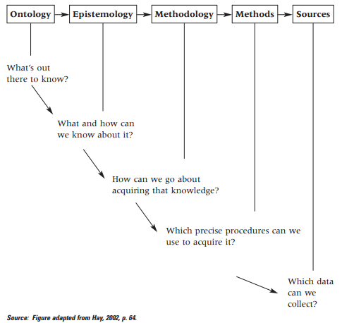
Figure 4: Relation between key research terminologies as shown by Grix (2002)
Reflecting on above discussion in relation the demarcation between various research terminologies suggests that case study is a methodology rather than a method. However, confusion can arise when ‘method’ and ‘methodology’ are used interchangeably by mistake (Walter, 2010). This differentiation becomes clearer in section 6 which discussed the methods that can be deployed under the case study methodology.
  - Impact of Epistemological position of key researchers on their approach towards case studies:
Yazan (2015) analysed the epistemological position of the three key researchers who have elaborated the case study approach towards research: Yin, Stake, and Merriam. Their epistemological orientations determine the way they explicitly or implicitly approach the cases study methodology (Yazan, 02015).
According to Yazan’s analysis, Yin’s orientation is more towards positivism whose three main notions are objectivity, validity and generalizability as demonstrated by his focus on the four aspects related to the design quality: construct validity, internal validity, external validity, and reliability. These aspects provide the basis of structured and well-defined approach towards the case-study methodology that Yin advocates. Yazan explained about Yin that “he presents a definitely detailed and comprehensive approach to the formation of the design with a highly scrupulous look at every step of the research process from construction of the research questions to collection and analysis of data in light of prior theoretical propositions to the reporting of the entire investigation”. Yin, however, does not explicitly mention his epistemological position and favours implementing a mix of qualitative and quantitative methods in the case study design (Yin, 2009).
On the other hand, Stake (1995) and Merriam (2009) approach case study from social constructivist paradigm (Hyett et al., 2014). Stake consider the matter of study or the case to be the central aspect of case study research rather than the methodological choices made to conduct the study (Stake, 1994). The cases come with both qualitative and quantitative aspects associated with them e.g. a sick child that comes to a medical practitioner. Though the ‘case’ has both qualitative and quantitative aspects, the physician may focus more on quantitative aspects depending on the problem and context. On the contrary, a social worker may be more interested in studying the qualitative aspects linked to the child. With this stake mentions that case studies are recorded in a number of fields because of what they study rather than how they study. Yazan considers Stake’s approach as constructivism and existentialism (non-determinism). In line with this, Stake considers the role of the qualitative researcher to be that of an interpreter, and gatherers of interpretations which require them to report their rendition or construction of the constructed reality or knowledge that they gather through their investigation. Merriam is more closely aligned to Stake as compared to Yin (Yazan, 2015).We accordingly see a high level of flexibility in research design proposed by Stake and Merriam as opposed to Yin (as explained in a later section in this paper).
Skate (1995) mentioned that the research design should evolve during the research as it cannot be defined in advance – a concept known as ‘progressing focussing’ (Meyer, 2001) which may bring Stake’s approach closer to grounded theory.
However, Meyer (2001) and Yazan (2015) highlighted that the prime difference between the case study and other qualitative designs (such as grounded theory) is that the case study can deploy the ‘theory’ and ‘conceptual categories’ in order to structure the research and analyse the data. It is not as open-field as the grounded theory in which knowledge about what is being studied is not available until the time a significant amount of first-hand data is analysed (McCallin, 2009). This is in alignment with Yin’s approach who advocate the use of case study for inquiries into theoretical propositions (Yin, 2009). Meyer (2001) supports this point of view and explains that without a theoretical framework researchers can potentially provide descriptions without the meaning and the lack of pre-understanding would cause undue time-spending on identifying the basic facts.
Discussion on paradigmatic positions and their evolution in the realm of case study research are further elaborated in section 6.1.
- METHODS:
The case study is not a research method by itself (Willig, 2013). Rather, researchers deploy various data collection and analysis ‘methods’ which produce information and materials appropriate for use in studying cases under the case study methodology (McLeod, 2008). In this section, we have presented a synthesis of literature regarding methods suitable for application under case study research. It is to be noted that these methods are not same historically. Accordingly, we have first presented a historical overview of the evolution of method selection within case study methodology.
  - Historical Perspective and Evolution of Case Study Methodology:
After the world war II, the most widely utilized methodology in social research was quantitative in nature and commonly used methods were experimentation, cause-experiments, and surveys which were considered as ‘scientific’ and other approaches, mainly qualitative ones, were considered as non-scientific (Simons, 2009). These methods failed to explain the ‘how’ and ‘why’ questions associated with the intended outcomes from the educational research at that time. Accordingly, the decision makers needed more detailed insights into the specifics (Simons, 2009).
Case studies gained popularity approximately 5 decades ago when a quiet methodological revolution was taking place and qualitative approaches were coming up as alternate strategies challenging the prevalent positivist approaches and quantitative methodologies (Simons, 2009). In the late 1960s, a breed of case study began to gain wide acceptance as it established linkages between positivism and hermeneutics and interpretations as an alternate philosophical foundation (Johansson, 2003).
Case studies historically focussed on ‘participant observation’ and ‘field research’ as a data collection methods, however, this trend changed in the second generation of case studies, post-1960s, which began to deploy ‘grounded theory’ more frequently (Johansson, 2003). The grounded theory approach, based on inductive methodology, aims to understand and interpret participant’s perspectives and generate theory from them (Johansson, 2003; Simons, 2009).
The next step in the evolution of case study research was the work of Robert Yin who further integrated experimental logic into the field of naturalistic inquiry [i.e. studying the objects or cases in their natural contexts (Lane, 2009) and going beyond the grounded theory based approaches] and qualitative methods (Johansson, 2003). The parallel school of case study researchers was based on works of scholars like Robert Stake who also gained wide acceptance among academic circles (Hyett, Kenny, & Virginia Dickson-Swift, 2014). Johansson (2003) explained that the aim of these second generation case study researchers was to make methods explicit, unlike their first generation counterparts.
After that, a number of researchers have made prominent contributions to the field of case study research. Some of this later research has tilted toward eclecticism [an approach in which sticking to a single paradigm is not necessary and researchers can draw from multiple theories, styles, or ideas to concoct a research design (Marble, 2000)] and pragmatism [a philosophy that seeks to clarify “hypothesis by identifying its practical consequences” (Hookway, 2016) using various methods (Tartakow, 2012; “Types of research,” 2009)]. Michael Quinn Patton, one of the case study researchers mentions: “Rather than believing that one must choose to align with one paradigm or the other, I advocate a paradigm of choices. A paradigm of choices rejects methodological orthodoxy in favour of methodological appropriateness as the primary criterion for judging methodological quality”. Groat and Wang (2013) identified that this approach of combing methods is practiced by researchers across a range of different disciplines. It is evident from figure 5 that case study is serving as a bridge between the qualitative and quantitative methodologies.
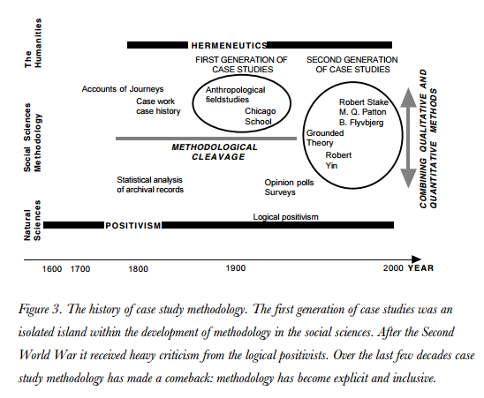
Figure 5: Evolution of case study research, as presented by Johansson (2003)
Meyer (2001) pointed out that unlike qualitative or quantitative research strategies, most of the design decisions in case study research are based on researchers and they have to do correct decision-making to ensure the quality of the study. Meyer recognizes this as strength as well as a weakness of this approach. It is strength in a way that it allows flexibility and ‘methodological appropriateness’ whereas the weakness arises when the decision making is not correct. Meyer highlighted that it is this reason that has resulted in many poor case studies, mainly quantitative, which opens up this methodology for criticism. To avoid this and ensure the quality of research, decisions are required to be made in a principled way.
Section 6.2 will present an overview of various research methods that need to be considered during the principled decision-making process for the case studies.
  - Contemporary Approach:
Case study research can collect data and evidence from a variety of data sources (Feagin et al., 1991; Meyer, 2001; Yin, 2006), however, selection of methods by researchers is often determined by factors such as time, finances and access to information (Meyer, 2001). It is accordingly important to understand the recommendations from prominent researchers and then find the best fit for research problem at hand.
Robert Stake believes that the key focus of case study research is not the methods but the actual cases (Stake, 2013). In his book Multiple Case Study Analysis, Robert Stake has provided a reference from (Yin, 1994) showing that he also held the same opinion. Though Yin and Stake believed that case studies are about cases and not about which methods are deployed, they have both recommended some methods that consider more suitable for case study research.
The first thing to note is the Yin (2006, 2013) suggested the use of more than one method to study the case. According to Yin, the quantitative and qualitative data collection methods should be combined in accordance with specific case or cases being explored. He highlighted that using one method alone can sometimes lead to constraints in terms of output. As an example of that, he mentions interview situations where interviewees say what they generally say to the outside i.e. ‘an organizational mantra’ which may or may not reflect the reality on the ground. In such situations, tapping from a variety of sources would ensure that the on-ground realities are identified with a low probability of an error (Yin, 2006). Those researchers who are inclined to utilize only one method of data collection can possibly be less attentive to other forms of evidence and rely on a narrow evidentiary base which can negatively impact the research outcomes (Yin, 2006).
Yin presented six methods which he considered more most suitable for case study research (Yin, 2006). This includes documents review and analysis, review of archival records, interviews, direct observations, participant-observation [e.g., “being identified as a researcher but also filling a real-life role in the scene being studied” (Yazan, 2015)], analysis of physical artefacts . However, it needs to be noted that Yin (2013) explained that these six, though used most commonly, are not the only sources for acquiring data for case study research and the complete list of sources can be quite extensive. There are many researchers who have also adopted and recommend this approach suggested by Yin to utilize methods from quantitative, qualitative or mixed-method investigative paradigms (Baxter & Jack, 2008; Labaree, 2016; Runeson & Höst, 2009).
Stake advocates the exclusive use of qualitative data sources (Stake, 1995) and his recommended data gathering methods include observations, interviews, and document reviews. Like Stake, Merriam also suggested an exclusive use of qualitative data sources and recommended the same methods as Stake i.e. observation, interviews and document analysis (Yazan, 2015).
- TYPES OF CASE STUDY RESEARCH:
Milliot (2015) explained that case study research can be classified based on ‘research design’ and ‘research purpose’. Zucker (2009) highlighted that there are a number of different types of case studies based on their characteristics, however, they are not necessarily mutually exclusive (Crowe et al., 2011). Accordingly, we do see some overlap in the ‘types’ explained by key researchers. Schell (1992) also pointed out towards this overlap. He explained that exclusivity does not exist between exploratory, descriptive and explanatory case studies and referenced from Yin’s works as an example. He mentioned that reviewing the best case studies suggests that they are either ‘exploratory and descriptive’ or ‘descriptive and explanatory’.
Following is an overview of different types of case study research as explained by key contributors to the field of case study research as per the two basis of broad classification suggested by Milliot.
  - Types of case studies depending on the ‘research purpose’:
There are 8 types of case study research based on the ‘nature of problem’ as explained below (with certain overlaps with each other not being mutually exclusive).
    - Exploratory case study research:
Eisenhardt proposed a simple and clear definition to this type of research. He pointed out that exploratory research is well-suited to research areas which are ‘new’ or ‘less explored’ and existing theory available about the research problem is inadequate (Eisenhardt, 1989; Hoffmann, 2008).
Yin explained that this type of case study is useful in situations where the interventions or the case being analysed or evaluated has no clearly defined or articulated outcomes (Yin, 2003). This assists researchers in identifying the on-ground situation, finding the fresh insights, bringing forward new ideas and propositions for further research (Runeson & Höst, 2009).
Eisenhardt explained that exploratory research compliments the ‘incremental theory building’ approach considering its utility in the initial stages of research when new perspectives are being identified (Eisenhardt, 1989).
    - Explanatory case study research:
This type of case study research is considered useful when “seeking an explanation of a situation or a problem, mostly but not necessary in the form of a causal relationship” (Runeson & Höst, 2009) which may involve verification of existing theories in confirmatory studies.
Yin linked the usefulness of this type of case studies to situations in which the presumed causal links in the real-life interventions are considered too complex for the survey or experimental strategies (Yin, 2003). Yin also highlighted the usefulness of explanatory case study and how it links the implementation of programs or interventions with their outcomes and effects.
    - Descriptive case study research:
Yin (2012) explained the most common type of case study is the descriptive case study. This type of case study is applied when a situation, intervention or a phenomenon is required to be described in depth (Runeson & Höst, 2009) in the real life context in situations when the phenomenon is of secondary importance (Milliot, 2015). Yin (2012) has also defined certain cases and situations which favour implementation of this type of case study research as shown in figure 6.
Yin (2012) explained that though this type of case study appears to be simple to undertake, in practicality, it can be quite challenging. Rather than describing ‘everything’, researchers need to keep in consideration the very purpose of the study and accordingly keep their focus on the objective. This accordingly provides ‘boundaries’ for the case studies.
Descriptive case study research is also one of the three types of case studies mentioned by Merriam (2009) which she proposes is for situations where a rich description of the case is required. Descriptive case studies are also known as ‘atheoretical’ and ‘configurative-idiographic’ (Kaarbo & Beasley, 1999).

    - Intrinsic case study research:
Stake recommended intrinsic case studies for use by those researchers who have a genuine interest in ‘understanding the case’ as opposed to theory building or exploring an abstract or generic phenomenon (Baxter & Jack, 2008). The purpose of this type of case study is to acquire a deeper understanding of a clearly defined case (Crowe et al., 2011). Though generalization is not the objective of this type of case study, the reader can generalize the findings through the process of ‘naturalistic generalization’ (Johansson, 2003) by gaining insights through reflection on the case study and recognizing similarities with the situations they are familiar with which leads to generalization (Melrose, 2010).
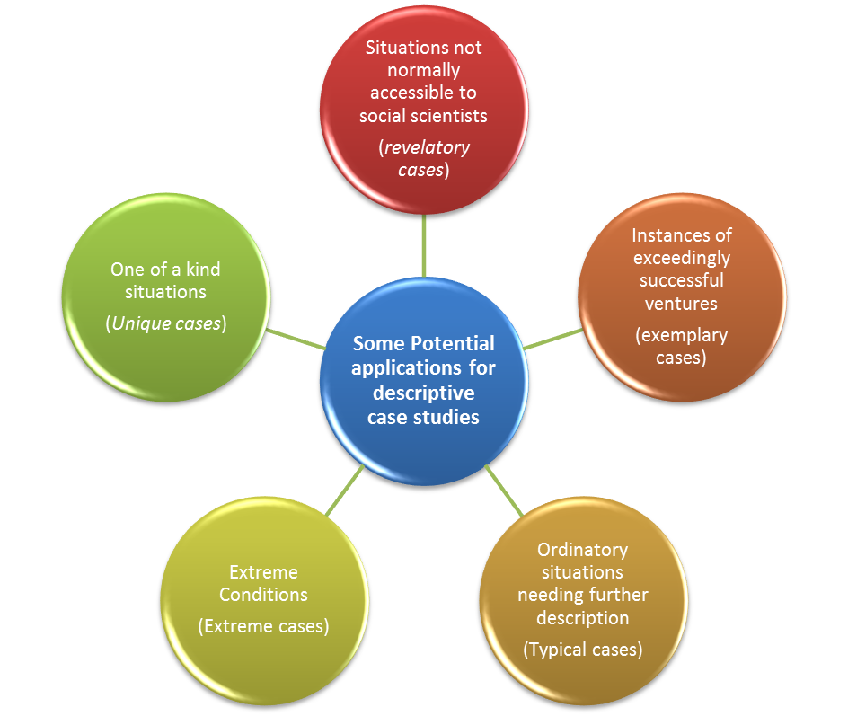
Figure 6: Potential Applications for descriptive case study derived from the explanation provided by Yin (2012)
    - Instrumental Case Study:
Stake (1995) introduced Instrumental case studies as a type of study that goes beyond simply understanding the issue and assists in acquiring further insights and refining a theory. In this type of case study research, the focus is not the case in itself (though it is looked at in depth in terms of its context, relevant activities and other aspects) but it is meant to play a supportive role in order to gain understanding and insights about something else – i.e. an external interest (Baxter & Jack, 2008) such as an issue or a phenomenon (Crowe et al., 2011). Baxter and Jack further explain that in this type of case study, “the case may or may not be seen as typical of other cases” (Baxter & Jack, 2008).
    - Particularistic Case Study
Merriam (2009) defined particularistic case study as the one focusing on a particular case such as a specific phenomenon, community, group, organization, intervention, program, institution, event, person, or group. This brings it close to the Intrinsic case study, as pointed out by Lohr (2008).
However, the difference between particularistic case study and intrinsic case study is that the latter’s core focus is understanding a particular case with no intention to build a theory or understand abstract constructs unlike the former which studies particular cases because of the phenomenon they represent (Merriam, 1998). The insights obtained from the case can be used to form advice for certain situations and illuminate a general issue (Lohr, 2008). Interestingly, this second explanation brings particularistic case studies close to Instrumental case studies.
From these two explanations, we interpret particularistic case study to have an overlap with both intrinsic and instrumental case study.
    - Confirmatory and heuristic case study research:
Milliot (2015) explained that confirmatory case study research is used when robustness or weakness of a theory is being evaluated. In such studies, a conflicting case is usually used to check some situations contradictory to the theory. If the theory is proven false, it then needs to be modified.
Not all the researchers use the name ‘confirmatory’ for this type of research. For example, from the three types of research proposed by Eisenhardt (‘Description’, ‘Theory Testing’ and ‘Theory generation)’ confirmatory case studies seem to be very close to ‘theory testing’ (Hoffmann, 2008; Runeson & Höst, 2009).
It is to be noted that confirmatory case studies have got some similarities with heuristic case studies (proposed by Merriam) which “bring about the discovery of new meanings, extend the reader’s experience, or confirm what is known” (Merriam, 2009, p. 44).
    - Comparative case study:
Goodrick (2014, p. 1) defined comparative case study as follows: “Comparative case studies involve the analysis and synthesis of the similarities, differences and patterns across two or more cases that share a common focus or goal”.
Goodrick further explained that in order to effectively conduct this type of case study, features from both the cases and rationale for their selection (which should be linked to research questions) need to be described in details at the very beginning.
  - Types of case studies depending on the ‘research design’:
In this section, we have summarized the types of case study research on the basis of their design considerations.
    - ‘Single Case’ Case Study
The focus of this type of case study is on a single case which warrants greater attentions and devotion from researcher to that case (Yin, 2006). Rowley (2002) and Yin (2013) explained that single-case study is more suitable in situations where theory testing, identifying new information and studying of unordinary cases is being undertaken.
A commonly highlighted limitation of the single case study is its lack of potential for in generalizability and information-processing biases (Eisenhardt, 1989; Meyer, 2001). The possibility and process of generalization from the case study research is undertaken in further on in this paper.
    - ‘Multiple-Case’ or ‘Collective’ Case Study:
Rowley (2002) explained that multiple case studies are considered similar to multiple experiments in some ways. If the number of cases considered in the study is higher, it would increase the robustness of the outcomes (Yin, 1994; Meyer, 2001; Bengtsson, 1999) as the chosen cases could be selected for replications, deliberate and contrasting comparisons, or hypothesized variations (Yin, 2006). Multiple cases reduce researchers’ and respondents’ biases (Yin, 1993).
This type of study enables the researcher to analyse differences within and between the cases with an objective to replicate the findings across cases (Yin, 2003). Accordingly, in order to select the cases for the multiple case study research, following two approaches need to be considered (Rowley, 2002; Yin, 1994):
- Literal replication - where the cases support each other or produce similar results
- Theoretical replication – where cases produce different results due to predictable reasons associated with different theoretical conditions
Rowley (2002) provided a guideline for interpreting the results of multiple case studies by explaining that if the prediction stands true about all the cases then propositions have a strong evidence for being valid. However, if a variety is seen in the outcomes, then it may be required to revisit the propositions.
Multiple case studies can be used in most situations where single-case studies are used to yield increased robustness in results, however, their utilization in extreme, unique, critical and revelatory cases is limited (Bengtsson, 1999) due to the individual nature of these cases.
It is important to note that Yin used the term ‘Multiple-case study’ whereas Stake coined the term ‘Collective Case study’(Baxter & Jack, 2008). However, Yin (2003) highlighted that nature and description of multiple and collective case studies is the same (Baxter & Jack, 2008). The multiple cases included in collective case studies can be either studied ‘simultaneously’ or ‘sequentially’ to illuminate the issue being explored (Crowe et al., 2011).
    - Holistic Case Study:
Holistic case studies (which can be ‘single’ or ‘multiple’) have one unit of analysis for each case (Yin, 2009), as shown in figure 7. Figure 7 clarifies that holistic case studies can be the single or multiple case. Yin explained that this type of case study is employed when there are no logical subdivisions possible for the units of analysis and when the underlying theory is of holistic nature. A potential problem associated with this design selection is the study of cases at a very abstract level which can result in important specific information about the cases remaining uncovered during the study (Yin, 2009). Accordingly, researchers are required to analyse the situation and their research problem before adopting a particular case study design.
    - Embedded Case Study:
If embedded sub-units are studied within the case study for given case(s), the study is referred to as embedded case study (Yin, 2013). Yin (2012, 2013) presented numerous examples for this type of research design. In one of the examples, he referred to case where the objective was to identify how and why an organization implemented certain staff promotion schemes at the holistic level. Embedded units of analysis in this study could be certain staff groups (Yin, 2012).
Embedded case study can also be either single or multiple as shown in figure 7.
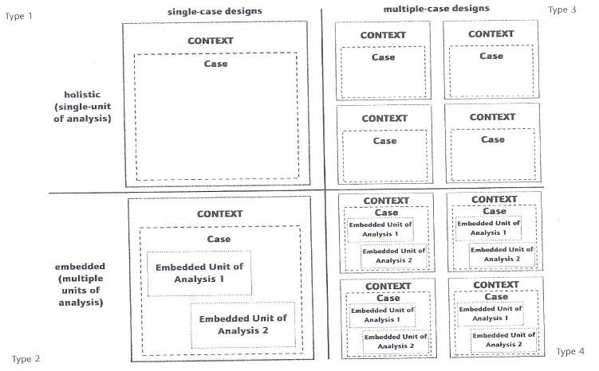
Figure 7: 2 x 2 Matrix - Single, multiple, holistic and embedded case studies based on Yin’s (2009, 2013) explanation
- LEVEL OF FLEXIBILITY IN CASE STUDY DESIGN:
In terms of flexibility in design, we see one clear distinction between the works of two key researchers in the field of case study – Yin and Stake. Willig (2008) provides a comparison between ‘naturalist’ and ‘pragmatic’ case study design. She explained that the approach which studies the case in a particular natural and real-world context without any propositions or pre-conceived theories is known as the naturalist type of case study research. She identified Stake as belonging to this school of thought. Contrary to this, she classified Yin’s approach as pragmatic. Pragmatic case study design follows certain propositions and research questions which are studied by utilizing a mix from qualitative and quantitative methods while recognizing that the methods come with some form of limitation (“Types of research,” 2009). Willig (2008) also explained that all activities in this type of research hinge on the propositions and research questions.
Stake (1995) explained that the flexible design is useful in enabling researchers to make major changes even after the research has commenced (Stake, 1995). He urged the researchers to do ‘progressive focusing’ which “requires that the researcher be well acquainted with the complexities of the problem before going to the field, but not too committed to a study plan. It is accomplished in multiple stages: first observation of the site, the further inquiry, beginning to focus on the relevant issues and then seeking to explain” (Stake, 1981). Though Stake did not suggest chalking down a full plan in advance, he did offer an explanation to various design considerations.
Section 9 explains the 5 key elements of case study design according to Yin based on the pragmatic approach which builds includes the identification of propositions for the research.
- ELEMENTS OF A CASE STUDY:
Researchers have elaborated the key elements of case study research (Yin, 2009, 2013; Perry, 2004; Rowley, 2002; Zucker, 2009). This includes problem/ study questions, propositions, units of analysis / cases, determination of how the data is linked to propositions and criteria to interpret the findings.
Following is an explanation for each of the five elements:
  - Problem/ Study questions
Yin suggested that the first element of a case study is a set of well-defined questions (Yin, 2006). However, as discussed in the previous section, some researchers advocate for an open design for exploratory research. In those situations, questions get formulated in the later stages of the study. However, even in those studies, the purpose of research still needs to be clear to the researcher (Rowley, 2002).
  - Units of analysis / Cases
Case refers to the object of study [a specific, complex, functioning entity (Stake, 1995)], which may contain one or more units of analysis [such as an institution, organization, person, event, community, project, intervention, program, department etc.] (Rowley, 2002; Runeson & Höst, 2009; Merriam, 2009) within a bounded context (Baxter & Jack, 2008; Johansson, 2003; Merriam, 2009; Stake, 1995). Johansson explained that a case can be theoretical, empirical or both. He also pointed out that case has to be specific to the time and space. Stake (1995), Meyer (2001) and (Melrose, 2010) highlighted that the cases in social and human sciences are purposively selected based on theoretical aspects, as opposed to selection based on random sampling or statistical aspects. Adding further weight to this point, Seawright and Gerring (2008) have explained the non-representative nature of sampling through random or statistical methods when applied for case selection through relevant calculations.
Researchers can come across a number of constraints while selecting the cases for their studies and they accordingly move towards pragmatic approach (Seawright & Gerring, 2008). Some of these situations could involve:
- Constraints related to accessibility to participants or data collection points (Labaree, 2016; Rowley, 2002)
- Resources constraints e.g. travel expenses etc. (Rowley, 2002)
- Time constraints e.g. a study requiring an unfeasible time for data collection and analysis (Labaree, 2016)
- Expertise to handle the case and financial requirements (Seawright & Gerring, 2008)
- Requirement to choose from more than one representative case (Yin, 2006)
Seawright and Gerring (2008) explained that selecting cases based on pragmatic approach, because of the above mentioned or other constraints, can impact the quality of outcomes from the research and accordingly, purposive selection has to be made while considering relevant quality related aspects. Many researchers have laid out recommendations regarding the purposive selection process for the cases. A summary has been compiled below which highlights the key aspects regarding the selection.
- Case selection should be in accordance with the research aims, questions, propositions and theoretical context (Rowley, 2002)
- Case may be selected intrinsically due to researcher’s interest in understanding a particular case (as explained earlier)
- Labaree (2016) proposed a set of very useful 5 questions that can guide the researchers in selecting suitable cases for their studies (as shown in figure 8).

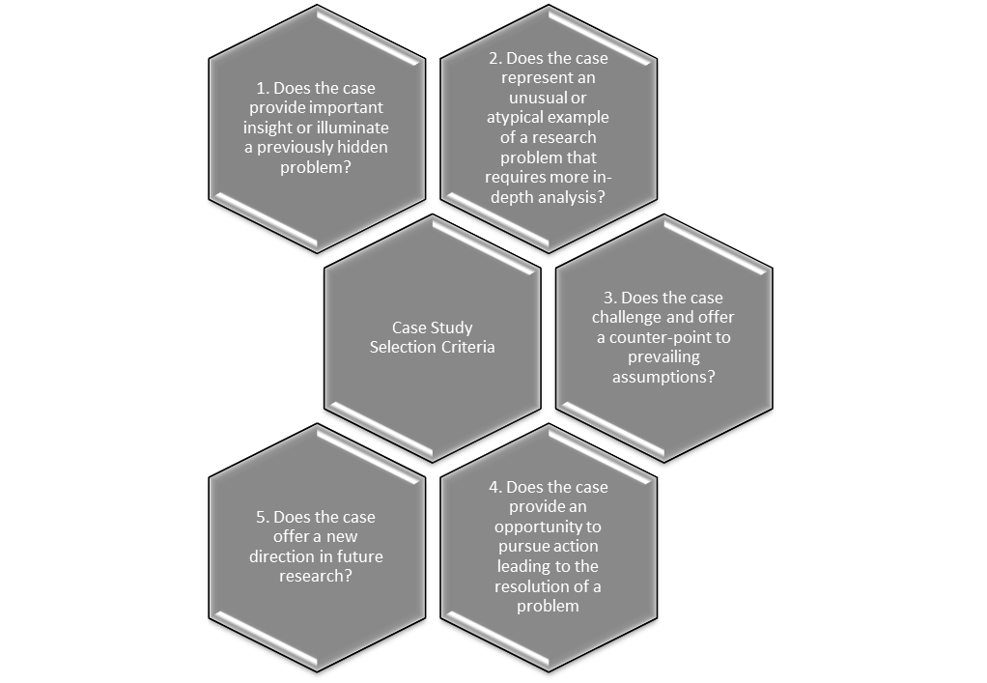
Figure 8: Case Selection Criteria proposed by Labaree (2016)

- In addition to case selection with an intrinsic approach, (Melrose, 2010) and Stake (1995) highlighted that a case can also be selected purposefully or analytically for its features and associated aspects [such an opportunity to provide rich information, being unique, critical, revelatory, or extreme (Stake 1995; Meyer, 2001)] with an interest towards generalization, extending the emergent theories (Meyer, 2001).
- Yin (2006) highlighted that in situations where more than one qualified cases are available (e.g. when a typical, critical or longitudinal case is researched), a formal screening procedure is required to ensure that objectives of the study are effectively met. Yin suggested this screening to be based on documents review and querying about the participants. Important criteria in this regard can include the willingness of participants, the richness of data available from a particular case and relevance of case to the research.
- Yin (2006) also proposed the selection criteria for cases in multiple-case studies design. He explained that in addition to considerations mentioned above, researchers have to keep in mind if the cases sought are to be confirmatory (to study the replication of some phenomenon), contrasting (success and a failure of a concept or theory), or theoretically diverse (from diverse sources or backgrounds). Variations from geographic, ethnic, size, or other related perspectives may also be important to consider.
Once case or cases are finalized, it is important to place boundaries on them to keep the research manageable and within scope (Yin, 2003; Stake, 1995; Rowley, 2002). This is required to avoid the common pitfall in which research expands the scope uncontrollably in the pursuit of answering questions with too many associated objectives or too much of breadth. Cases can be bounded by various factors. Some commonly used factors are mentioned below:
- Time (Creswell, 2002; Stake, 1994)
- Place (Creswell, 2002)
- Activity (Stake, 1994)
- Definition (M. B. Miles & Huberman, 1994)
- Context (M. B. Miles & Huberman, 1994)
  - Propositions
After placing the boundaries on cases, the next logical step is identifying the propositions (Baxter & Jack, 2008). The use of propositions in the case study is similar to that of hypothesis (Baxter & Jack, 2008; Klein & Myers, 1999; Yin, 2003) and it is defined as a declarative statement or a proposed explanation for an aspect, concept, activity or the phenomenon being studied (Avan & White, 2001; Klein & Myers, 1999). In other words, propositions are researchers’ speculations about what the outcomes of the study are going to be (Rowley, 2002; Skogerbø, 2011) which are either proved correct or incorrect in the light of data collection and analysis in the later phases of research.
Propositions are formulated based on literature review, relevant experience, earlier evidence, theories, and/or generalizations driven from the empirical data (Baxter & Jack, 2008; Yin, 2012). Yin (2003) also gave importance to the circumstances in which the propositions are believed by the researcher to be true. He accordingly suggested a clear specification for those circumstances.
Propositions play an important role in the case study research [considering the positivist point of view (Rowley, 2002) which urges their definition before the data collection], but they are not defined in advance in some types of case study research design e.g. when description of a situation is required, theory building is the objective, inductive approach is adopted or the case is studied only due to the intrinsic interest in the case (Baxter & Jack, 2008; Rowley, 2002).
The presence of clear and specific propositions would help to contain the scope of study within defined boundaries and accordingly increase chances for project completion (Stake, 1995; Yin, 2003; Baxter & Jack, 2008).
Stake (1995) highlighted that researchers can have several propositions which should all have a well-defined area of focus and objective as they are to guide the later phases of research including data collection and the following analysis. However, having too many propositions can overwhelm the novice researchers during data analysis and reporting step (Baxter & Jack, 2008) and they should accordingly pay attention to this aspect while selecting the propositions for the study.
  - Determination of how the data is linked to propositions
Baxter and Jack (2008) highlighted that propositions and issues (‘issues’ is the term Stake used to define what Yin referred to as ‘proposition’) play an important role in the formulation of a conceptual framework which serves as a tool to guide the research process. The framework identifies the constructs which are then used in the data collection process (Baxter & Jack, 2008). Data in case studies is collected from multiple sources which then converge like pieces of puzzles to provide a greater understanding of the case (Baxter & Jack, 2008). Data analysis is “the process of making sense out of the data... [which] involves consolidating, reducing, and interpreting what people have said and what the researcher has seen and read – it is the process of making meaning” (Merriam, 1998, p. 178). According to Yin (2003), the data analysis includes examining, categorizing, tabulating, testing, or recombining the quantitative and qualitative evidence to match with the propositions defined for the study.
In order to link these pieces of puzzles and the final picture to the propositions, researchers have devised various methods (Yin, 2003; Max Herold, 2009; Reus, 2006; Kohlbacher, 2006). Yin (2003) highlighted that researchers have to keep in mind these linking strategies in mind at the design stage so that they can be accommodated in the data collection plan. For example, if time-series analysis (explained later on in this section) is required to be used, researchers can place time markers in the data collection plan. Researchers who do not consider these aspects in advance often have to go back to the data collection phase (Yin, 2013).
Following is a comparison between the methods proposed by Yin, Stake, and Merriam.
Table 2: Comparison of methods of analysis proposed by Yin, Stake, and Merriam
Yin (2006) | Stake (1995) | Merriam (1998)
Pattern Matching, Time-Series Analysis, Logic Models,  Explanation Building, Cross-Case Analysis. | Categorical Aggregation, Direct Interpretation. | Ethnographic analysis, Narrative analysis, Phenomenological analysis, Constant comparative method, Content analysis, Analytic induction.
Explanation of all of these methods is considered to be beyond the scope and objective of this paper. However, we have included a brief overview of 5 methods of analysis proposed by Yin.
- Pattern matching:
Pattern matching is used to ‘match’ the observed patterns (from collected data) with the expected pattern (i.e. propositions) to find if they support each other or not (Hak & Dul, 2009; Yin, 2009). This accordingly is applicable for research which has pre-defined propositions.

- Explanation building:
Yin (2009) explained that explanation building is a special type of pattern matching and is only valid for explanatory case studies. He explained that the parallel to this explanation building procedure in the exploratory research realm is what is known as the “hypothesis-generating process” which is not meant to conclude the study but to generate hypothesis for further testing. In the explanation building process, an initial case is first compared against the propositions. Based on that, the propositions are revised. Further cases are then matched against the revised propositions to gain further explanations. This process is done in an iterative manner as many number of times as required (Yin, 2009).

- Time-series analysis:
Time-series analysis is also a form of pattern-matching (Baskarada, 2014) however, it involves data collection and/or analysis of certain aspects related to the case over certain time intervals (Dwyer, Gill, & Seetaram, 2012). Yin (2009) explained that the main logic behind the time series analysis is either to match the observed data with a “theoretically significant trend specified before the onset of the investigation” or “some rival trend, also specified earlier” (Yin, 2009, p. 145).

- Logic models:
Logic models graphically represent how the situation would be impacted under various conditions and how the expected results would be achieved. It utilizes a number of if-then relationships to connect inputs to the outputs and eventually the outcomes (Kushner & Zaleski, 2014). A typical logic model includes the following components (Petersen, Taylor, & Peikes, 2013):
- Immediate and final outcomes from the process or series of possible events including the pathways or the routes through which the final outcomes are achieved.
- Interrelationships between various inputs, outputs, and outcomes
- Impact of outside factors from the given contexts
In the case study research, logic models are made by comparing the predicted cause-effect chain of events with the empirically observed evidence (Baskarada, 2014).

- Cross-case synthesis:
This method is applicable to multiple cases studies. The cases included in these studies can either be done as a planned step within the same research or conducted separately (Yin, 2009). In either case, Yin explained that the treatment and objectives are the same i.e. synthesis of information from the cases. In the case of a large number of cases, quantitative analysis techniques can be deployed. However, if the cases are fewer than alternate tactics are required to be considered which are not different to research synthesis or meta-analysis (Yin, 2009). In their study, Khan and VanWynsberghe (2008) created a novel database to achieve this purpose and “delineate the combination of factors that may have contributed to the outcomes of the case, seek or construct an explanation as to why one case is different or the same as others, make sense of puzzling or unique findings, or further articulate the concepts, hypotheses, or theories discovered or constructed from the original case”. They consider this type of analysis as a mean for better understanding of relationships between cases and building or refining the theories.
In contrast to the five techniques presented by Yin, Stake proposed categorical aggregation and direct interpretation as suitable methods for analysis (Baxter & Jack, 2008).
From the above explanation, it is very clear that data organization plays are a significant role with regards to linking data to the proposition and subsequent analysis. Accordingly, Yin and Stake have highlighted the significance of good data organization (Yin, 2009, Stake 1995). One of the methods to accomplish that can be using a database so that unprocessed data remains stored for future use. This also adds to the reliability of the study (Baxter & Jack, 2008). With regards to clarity in presenting the evidence obtained from data collection and analysis, Yin (2013) recommended using tables, illustrations, footnotes, charts, quotations from interviews, figures, other exhibits (including pictures).
It is important to note that in the case study research, the data analysis occurs concurrently with data collection to enable researchers make relevant adjustments to the research design and reach their desired goal (Yin, 2009; Stake, 1995; Merriam, 1998).
  - Criteria to interpret the findings
The criteria for interpreting the findings in the case study research are distinctively different from quantitative studies which use statistical methods (Yin, 2013). Yin explained that the criteria to interpret the findings in case studies involve identification and addressing of rival explanations (which are to be developed during the design phase) for the research findings. The more rival explanations are rejected, the stronger the findings from the case study become.
In addressing the rival explanations and presenting the evidence and interpretations leading to that, Yin (2006) highlighted the importance of maintaining clarity and keeping interpretations separate from the evidence to enable audience independently interpret the research data.
Klenke (2015) emphasized on another relevant aspect with regards to interpretations of the findings. She recommended that interpretation has to be done from two perspectives:
- Agreement between the findings and the literature “so that the theory is built replicating, consolidating or extending existing literature. Similar findings in different contexts lead to stronger theory. The support of existing theory (in other fields or disciplines) may lift the theory to a higher conceptual level” (p. 74).
- Any conflicts between the findings and the literature need to be examined in order to understand the nature of difference and its explanation in terms of any variation in approach toward the interpretation of the same data and any other particular or specific aspects.
From the reporting perspective, it is not necessary in case studies to report the findings at the end of the case study report. Rather they can be reported in other relevant chapters as well (Yin, 2003), however, the recommendations mentioned above need to be considered.
- CASE STUDY DESIGN AND PROTOCOL:
The case study research design is an action plan for moving from questions to conclusions in a coherent manner that ensures clarity about what a study is supposed to achieve (Rowley, 2002). This action plan accordingly comprises of many elements including the research questions, propositions, approaches towards quality assurance and standard of research, selection of methods and other aspects (Rowley, 2002).
Yin (2006) highlights various aspects of this ‘action plan’ or ‘design’ that includes a review of the literature to understand theoretical considerations, the definition of the questions for research, strategies for analysis, mechanisms and protocols for collection of data, development of appropriate instruments for data collection and presentation of findings in a suitable manner. The factor that makes case study design different is that the data collection and analysis happens at the same time and if one finding contradicts another, a researcher may modify the pre-planned action plan to meet the new requirements and to dig deeper into the difference in order to get detailed insights (Yin, 2006).
This aspect has also been highlighted by Johansson (2003) who explained that the cases in case study research can change during the process of research resulting in changes in boundaries of the methodology and the particular point of focus about the case. It is due to this reason that some researchers, Stake in particular, preferred loose structure for the case study which allowed evolution. Whereas Yin has provided a detailed framework to structure case study research (Yazan, 2015) though he also agrees that cases can change, as explained in the previous paragraph and earlier in this paper.
Above mentioned elements and aspects of the case study design have been organized by the researchers under relevant protocols alongside certain procedural requirements. Yin considers such case study protocols to be highly important for all types of case study research in terms of improving their reliability (Yin, 2013). The protocol provides a structure to the research and ensures its proper conduct. Yin (2013) highlighted following key benefits of having a protocol:
- It keeps the researchers focussed on the topic of case study research
- It assists them in anticipating potential problems and coming up with solutions for them
- It is useful in identifying the case study audience in advance and the reporting protocols
- Due to the nature of forethought, the protocol promotes, mismatches at later stages in research can be avoided.
Considering its importance in the case study research, we have compiled a comparison table showing broad protocols suggested by Eisenhardt (1989), Stake (1995) and Yin (2003) while building on the insights provided by Brereton, Kitchenham, Budgen, and Li (2008). Through the following comparison, we have found that the broad structure of the proposed protocol is similar in nature [in accordance with findings from Brereton et al. (2008)]. However, some differences exist as we drill down into the details. For example, Eisenhardt’s proposed steps clearly indicate that he advocated the formation of the hypothesis after the study. Similarly, we find Yin’s description to be different from others in terms of detailed procedural requirements and a need for the researcher to acquire competence in performing the relevant case study. It is also to be noted that some steps are not explicitly mentioned in some of the following protocols but are implied.
Table 3: Recommendation for key components of case study research protocol
[based on explanations provided by Brereton, Kitchenham, Budgen, and Li (2008)]
Phase | Eisenhardt | Stake | Yin
Overview of the case study and relevant questions and procedures | Define the research and priori question (hypothesis or theory is not to be defined) | Define the criteria for selection of cases. | Define the case study design (e.g. single or multiple case study, holistic or embedded, flexible or closed) including the five key elements of case study research.  (This also involves the literature review to form propositions)
 | Select cases while keeping the theoretical concerns and relevant population in consideration. | This next step involves identification of research questions (relevant to selected cases), potential issues (including potential cause and effect relationships), and information questions (which are more detailed than the main research question). | Acquire specific skills for data collection (e.g. interviewing etc.), develop a protocol, select the case(s), and conduct a pilot study.
Data Collection | Prepare data collection instruments using multiple methods  Enter the field (this includes a recording of the field notes in the data analysis and using flexible and opportunistic approach. | Organize for data collection, get permissions and gather the data through the use of methods such as observation, interview and document reviews. | Collect evidence using multiple methods, record them in a database and maintain the chain of evidence.
Data Analysis | Analyse the data within and across the case.  Develop hypothesis through iterative tabulation of evidence and looking for identified constructs, replication.  Identity the logic across the cases and explain those relationships.  Match the findings with similar or conflicting literature. | Analyse and interpret the data through aggregation by categories or direct interpretation.  Clearly define the role of case study researcher (e.g. interpreter, biographer etc.)  Triangulate and validate the findings including discussing the findings with the participants | Analyse the evidence based on an appropriate analysis strategy and deploying relevant analysis techniques.  Three key rules to be kept in consideration at this stage include:  - Attend to all the evidence  - Present the evidence separately from any interpretations  - Explore rival interpretations
Research Closure | Close the research when it is believed that theoretical saturation is reached (i.e. additional data will not bring any major changes to the existing results) | Write the report in appropriate style. | Report the case studies by identifying the relevant audience, the report structure, report review mechanisms and the writing process.

Based on the integration of suitable practices from the key researchers, Zucker (2009) came up with a very elaborate protocol. We found this protocol to be very usable for the new researchers and have accordingly included it in this paper, as below.
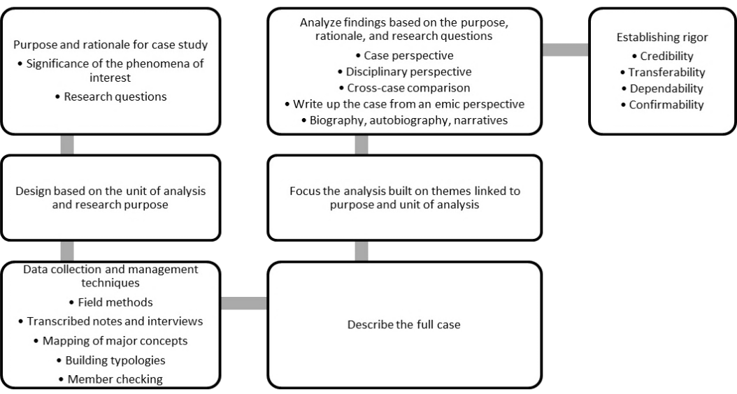
Figure 9: Case Study Protocol based on recommendations from Zucker (2009)
- MANAGING QUALITY IN CASE STUDY RESEARCH:
According to Stake (1995) and Merriam (1998), validity and reliability originated from the positivists traditions and their implementation in qualitative research is not possible in the same way as it is done in quantitative research. They accordingly explain that in the qualitative research, these aspects are addressed in a different manner.
Following is a synthesis of literature on validity and reliability from the case study research perspective:
  - Validity:
According to Stake (1995), validity is addressed through triangulation which can be in terms of source, investigator, theory or methods.
Merriam (1998) proposed six strategies to achieve validly which include triangulation, member checks, long-term observation, peer examination, participatory research, and disclosure of researcher bias.
Yin sub-divided the validity in three types: Construct validity, internal validity, and external validity.
- Construct validity: Construct validity refers to highlighting and removing subjectivity through the operational measures for ensuring linkage of data collection measures and questions with research propositions (Rowley, 2002). Yin (2003) and Rowley (2002) pointed out that this can be achieved the triangulating multiple sources of evidence, maintaining chains of evidence, and conducting member checks.
- Internal Validity: This type of validity is applicable in the case of explanatory or other forms of causal studies and not relevant for descriptive or exploratory studies as it involves the causal relationships which show how one condition or situation leads to the other (Rowley, 2002). Yin (2003) and Rowley (2002) explained that internal validity can be acquired by utilizing the analytical techniques recommended for a case study research (e.g. pattern matching etc.).
- External Validity: External validity deals with generalizability of research findings (Trochim & Donnelly, 2006). Rowley (2002) explained that it can be achieved through the use of replication logic in case of multiple cases and following the protocol. The concept of generalizability is discussed in detail in section 12.

  - Reliability:
Reliability deals with the repeatability, replicability and consistency of results with the re-use of the data collection methods (Leung, 2015; Rowley, 2002). Feagin et al. (1991) pointed out that the reliability in case study research can be achieved by detailed documentation of procedures and proper recording keeping. Yin (2003) re-emphasized the importance of following protocols and maintaining a database of research findings in order to achieve reliability. Rowley (2002) also advocated for using databases to ensure reliability. According to Merriam (1998), the three relevant strategies to ensure reliability are documenting and explaining investigator’s position with regards to the research being undertaken, triangulation, and use of an audit trail in the form relevant evidence collection and documentation. Though we see different words used by these researchers, the common themes that can be extracted from this are ‘recording and adhering to the research protocol’ and ‘ensuring proper documentation and recording of evidence with chains’.
- GENERALIZABILITY OF CASE STUDIES:
Lack of generalizability is highlighted as one of the potential weakness of case studies and some researchers believe that case studies cannot yield generalizable knowledge (Yin, 2011; Crowe et al., 2011; Tsang, 2014). However, case study researchers have two points of views about this. One of the points of views suggests that in certain types of case studies, generalizability is not an intended outcome (Yin, 2011; Thomas, 2010; Tsang, 2014) e.g. case studies dealing with unique cases. According to the second point of view, case studies generalize well and even considered more generalizable than quantitative studies due to certain factors (Tsang, 2014b). For the latter, comprehensive protocols have been devised by the researchers.
Generalizations from case studies are analytical in nature and not statistical (Yin, 2011, 2006; Johansson, 2003; Rowley, 2002; Teegavarapu, 2008; Klenke, 2015) i.e. they use ‘reasoning’ in the process of generalization for adding to known theories (Rowley, 2002). Yin explains that “analytic generalizations depend on using a study’s theoretical framework to establish a logic that might be applicable to other situations” (Yin, 2011b, p. 18). Macfarlan (2015) provided a very elaborate definition for analytical generalization. According to her, “Analytical generalisation involves making projections about the likely transferability of findings from an evaluation, based on a theoretical analysis of the factors producing outcomes and the effect of context”. She also explained that “analytic generalisation compares the results of a case study to a previously developed theory”.
Yin (2009) further laid out two steps in the process of generalization from case studies:

Step 1
CONCEPTUAL CLAIM
Case study researcher(s) show the relationships their studies have found about the concepts, theoretical constructs and certain sequences.

Step 2
EXTENDING THEORETICAL PROPOSITIONS
Theoretical propositions from the study are applied to implicate other situations in which similarity exists with current research in terms of concepts, constructs and sequences.

Figure 10: Two-step process for generalizing from the case studies as proposed by Yin (2009)
With regards to the concept of ‘theory generation’ and current discussion about generalization, it is important to understand that no single qualitative or quantitative study is likely to bring forth a new theory. Rather they generate theoretical frameworks, implications, or refinement of existing theories (Tsang, 2014b). In the process of overall theory building, case studies contribute by three ways: falsification, theoretical generalization, and empirical generalization [refer to figure 11 which is adapted from Tsang (2014b)].
Following is a brief overview of the three aspects of generalization related to case studies.
- Theoretical generalization “involves generalization from a study to a theory rather than a population” (Vaus, 2002, p. 148). This follows the inductive approach towards generalization. Johansson (2003) explained that “in case studies this is done through inductive theory-generation, or conceptualisation, which is based on data from within a case. The result is a theory normally consisting of a set of related concepts. According to Grounded Theory, this is the way in which generalisations are made”. Replication is considered to exist if two or more cases support the same theory (Klenke, 2015) and the theory supported by these cases is considered to be stronger when a higher number of cases support each other (Klenke, 2015; Rowley, 2002).
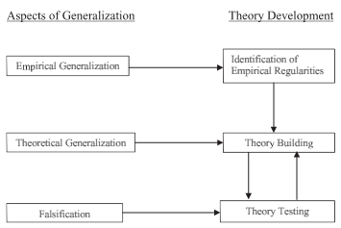
Figure 11: Contributions of case studies to theory development as shown by (Tsang, 2014b)
- In addition to the replication, falsification (or theory testing) is another way of generalization which weeds out the aspects that cannot be generalized (Tsang, 2014b). Generalization through falsification follows the deductive approach where a hypothesis or proposition is identified (in accordance with a theory or a proposed theory) which the research either confirms or falsifies (Johansson, 2003; Mayring, 2007).
- With regards to empirical generalization [which does not necessarily need to use statistical methods (Maxwell & Margaret Chmiel, 2014)], Tsang (2014b) explained that “empirical generalization concerns generalizing from the findings of a case study to the population from which the case or cases are drawn (statistical or within-population generalization) or to other populations (cross-population generalization)” (p.337). In doing so, consideration is given to regularities between the populations without much emphasis on understanding the reasons for those regularities (Tsang, 2014b). Tsang also pointed out that considering this definition, multiple-case research is more suitable for generalization with cases being preferred to be ‘representative’ for the population they are selected from. In such studies, context also needs to be well-understood by researchers and reported with the claims for generalization.
Apart from above three, there are two more types of generalizations usually associated with case studies.
- Naturalistic generalization is the process in which readers engage with the findings of one or more case study and analyze them in their own contexts and in the light of their own experiences. Based on this reflection, they can generalize some or all aspects of the findings for themselves (Stake, 1995).
- Generalization through abductive reasoning refers to generalization based on an uncertain best guess, logical assumption, proposition, explanation or conclusion based on findings from one or more cases (Johansson, 2003). Certainty about its validity and correctness cannot be claimed.
- CRITICISM FOR CASE STUDIES:
Yin (2013) highlighted the 5 key areas, as follows, where case studies receive a higher degree of criticism.
- Lack of rigor is highlighted as a concern most frequently (Yin, 2013). Yin explained that this mainly happens when case study researchers fail to adhere to case study protocols, partly due to lack of availability of relevant texts highlighting the recommended procedural guidelines. Crowe et al (2011) recommended the mitigating action for this to be the “triangulation, respondent validation, the use of theoretical sampling, transparency throughout the research process”.
- Yin also highlighted that some criticism is because of confusing that arises when ‘case study research methodology’ is not distinguished from the ‘case studies used in teaching’ which may be altered to emphasize certain points.
- Third commonly asked question to case study researchers is about the generalizability of findings from case studies. This aspect is covered above with reasonable details.
- Another point raised by the critiques is the unmanageability of the efforts in the case study research. They claim that in order to gain deep insights into the case, the volume of work becomes too big and unreadable. Yin considers it somewhat relevant based on the how the case studies were done in the past. He explained the right techniques to avoid this pitfall in terms of methods and structuring of report findings.
- The fifth type of criticism is centered on whether there is any comparative advantage of case studies over the other methodologies. Yin highlighted that the detailed insights that can be found through case studies, especially when ‘how’ and ‘why’ questions are being answered, no other methodology can offer.

- CONCLUSION
Due to the evolving nature of case studies, they have received certain criticism in the past. However, with the detailed protocol and comprehensive explanations by key researchers in the field, case study research is now considered a highly worthwhile exercise and is widely applied in numerous fields. This paper has summarized a number of key concepts related to case studies and presented a comprehensive overview of how it is implemented. In this article, we have seen that case study methodology can be very effectively deployed in a number of research situations and can yield desired research quality given the correct protocols are followed. This type of inquiry or study can be done with various objectives such as providing a description, exploring a situation or a concept, gaining insights into the explanations of certain relationships or even studying a case because an intrinsic interest. To fulfill needs of various kinds of research situations, researchers have proposed relevant designs and protocols considering important aspects such as identifying the research questions, making an appropriate selection of case, identifying propositions and considerations related to data collection and analysis. Due to this and other quality assurance factors embedded in the recommended approaches towards the case study research design, we have found that the results from the case studies can be generalized effectively and add to existing knowledge and theories. It is accordingly considered highly important for novice case study researchers to understand these approaches and techniques to ensure the validity and reliability of their research endeavors.

REFERENCES:
Avan, B. I., & White, F. (2001). The Proposition: An insight into research. Journal of Pakistan Medical Association. Retrieved from http://jpma.org.pk/full_article_text.php?article_id=2499
Baskarada, S. (2014). Qualitative case study guidelines. The Qualitative Report, 19(40), 1–25.
Baxter, P., & Jack, S. (2008). Qualitative case study methodology: Study design and implementation for novice researchers. The Qualitative Report, 13(4), 544–559.
Bengtsson, P. (1999). Multiple case studies–not just more data points. Term Paper in Graduate course in Research Methodology. Retrieved from www.citeseerx.istpsu.edu Accessed, 5/03/2014.
Berent, S., & Albers, J. W. (2012). Neurobehavioral toxicology: Neurological and neuropsychological perspectives, Volume I: Foundations and methods. Taylor & Francis.
Blaikie, N. (2009). Designing social research. Cambridge, UK: Polity Press.
Brereton, P., Kitchenham, B., Budgen, D., & Li, Z. (2008). Using a protocol template for case study planning. In Proceedings of the 12th International Conference on Evaluation and Assessment in Software Engineering (pp. 41–48). Swinton, UK: British Computer Society. Retrieved from http://dl.acm.org/citation.cfm?id=2227115.2227120
Bromley, P. D. B. (1990). Academic contributions to psychological counselling. 1. A philosophy of science for the study of individual cases. Counselling Psychology Quarterly, 3(3), 299–307. http://doi.org/10.1080/09515079008254261
Brown, P. A. (2008). A Review of the literature on case study research. CJNSE/RCJCÉ, 1(1). Retrieved from http://cjnse-rcjce.ca/ojs2/index.php/cjnse/article/view/23
Case report publication guidance: IRB review and HIPAA compliance. (2006). Retrieved May
25, 2016, from http://www.hopkinsmedicine.org/institutional_review_board/guidelines_policies/guidelines/case_report.html
Case reports - Health sciences campus institutional review board. (2016). [Tufts University]. Retrieved May 25, 2016, from http://viceprovost.tufts.edu/HSCIRB/case-reports/
Cavaye, A. L. (1996). Case study research: A multi-faceted research approach for IS. Information Systems Journal, 6(3), 227–242.
Creswell, J. W. (2002). Research design: Qualitative, quantitative, and mixed methods approaches (2nd edition). Thousand Oaks, California: SAGE Publications, Inc.
, S., Cresswell, K., Robertson, A., Huby, G., Avery, A., & Sheikh, A. (2011). The case study approach. BMC Medical Research Methodology, 11, 100. http://doi.org/10.1186/1471-2288-11-100
Darke, P., Shanks, G., & Broadbent, M. (1998). Successfully completing case study research: combining rigour, relevance and pragmatism. Information Systems Journal, 8(4), 273–289.
Dobson, P. J. (1999). Approaches to theory use in interpretive case studies–a critical realist perspective. In Australasian Conference on Information System, Wellington, New Zealand. Retrieved from https://www.researchgate.net/profile/Philip_Dobson/publication/228509820_Approaches_to_Theory_Use_in_Interpretive_Case_Studies--a_Critical_Realist_Perspective/links/54b659ee0cf2e68eb27e7cbe.pdf
Dwyer, L., Gill, A., & Seetaram, N. (2012). Handbook of research methods in tourism. Edward Elgar Publishing. Retrieved from http://www.elgaronline.com/view/9781781001288.xml
Eisenhardt, K. M. (1989). Building theories from case study research. Academy of Management Review, 14(4), 532–550.
Feagin, J. R., Orum, A. M., & Sjoberg, G. (1991). a case for the case study. UNC Press Books.
Fidel, R. (1984). The case study method: a case study. Library and Information Science Research, 6(3), 273–288.
Flyvbjerg, B. (2006). Five misunderstandings about case-study research. Qualitative Inquiry, 12(2), 219–245.
Frantz, J. M. (2009). Writing a case report for publication. JCHS, 4(2), 37–40.
Gerring, J. (2004). What is a case study and what is it good for? American Political Science Review, 98(2), 341–354.
Goodrick, D. (2014). Comparative case studies. Printed by UNICEF Office of Research, Florence, Methodological Briefs: Impact Evaluation No. 9.
Grix, J. (2002). Introducing students to the generic terminology of social research. Politics, 22(3), 175–186. http://doi.org/10.1111/1467-9256.00173
Groat, L. N., & Wang, D. (2013). Architectural research methods. John Wiley & Sons.
Hak, T., & Dul, J. (2009). Pattern matching. ERIM report series - Research in management, no. ERS-2009-034-ORG. Erasmus Research Institute of Management (ERIM), RSM Erasmus University, The Netherlands.
Hoffmann, N. (2008). German buyouts adopting a buy and build strategy: Key characteristics, value creation and success factors. Springer Science & Business Media.
Hookway, C. (2016). Pragmatism. In The Stanford Encyclopedia of Philosophy (Summer 2016 Edition). Retrieved from http://plato.stanford.edu/entries/pragmatism/
Hyett, N., Kenny, A., & Virginia Dickson-Swift, D. (2014a). Methodology or method? A critical review of qualitative case study reports. International Journal of Qualitative Studies on Health and Well-Being, 9. Retrieved from http://www.ncbi.nlm.nih.gov/pmc/articles/PMC4014658/
Hyett, N., Kenny, A., & Virginia Dickson-Swift, D. (2014b). Methodology or method? A critical review of qualitative case study reports. International Journal of Qualitative Studies on Health and Well-Being, 9. Retrieved from
http://www.ncbi.nlm.nih.gov/pmc/articles/PMC4014658/
Hymel, G. (2005). Research methods for massage and holistic therapies. Elsevier Health Sciences.
Isenburg, M. von. (2016). Introduction to evidence-based practice : Types of studies. Retrieved May 25, 2016, from http://guides.mclibrary.duke.edu/c.php?g=158201&p=1036068
Johansson, R. (2003). Case study methodology. Presented at the Methodologies in Housing Research (22–24 September 2003), Stockholm: Royal Institute of Technology and International Association of People–Environment Studies. Retrieved from http://www.psyking.net/htmlobj-3839/case_study_methodology-_rolf_johansson_ver_2.pdf
Kaarbo, J., & Beasley, R. K. (1999). A practical guide to the comparative case study method in political psychology. Political Psychology, 20(2), 369–391. http://doi.org/10.1111/0162-895X.00149
Klein, H. K., & Myers, M. D. (1999). A set of principles for conducting and evaluating interpretive field studies in information systems. MIS Quarterly, 67–93.
Klenke, K. (2015). Qualitative research in the study of leadership. Emerald Group Publishing.
Kohlbacher, F. (2006). The use of qualitative content analysis in case study research. Forum Qualitative Sozialforschung / Forum: Qualitative Social Research, 7(1). Retrieved from http://www.qualitative-research.net/index.php/fqs/article/view/75
Kushner, J., & Zaleski, K. (2014). Introduction to logic models. University of Wisconsin. Retrieved from http://www.slideshare.net/wicampuscompact/introduction-to-logic-models
Labaree, R. V. (2016). Research guides: Organizing your social sciences research paper: Writing a case study. University of Southern California. Retrieved from http://libguides.usc.edu/writingguide/casestudy
Lane, D. R. (2009). Naturalistic inquiry [University of Kentucky]. Retrieved May 12, 2016, from http://www.uky.edu/~drlane/methods/ch10.htm
Leung, L. (2015). Validity, reliability, and generalizability in qualitative research. Journal of Family Medicine and Primary Care, 4(3), 324–327. http://doi.org/10.4103/2249-4863.161306
Lohr, K. D. (2008). Lasting expressions: A case study of lifelong learners in a life-story process (Doctor of Education Dissertation). North Carolina University, USA.
Macfarlan, A. (2015). Analytical generalisation. Retrieved May 23, 2016, from http://betterevaluation.org/evaluation-options/analytical_generalisation
Marble, R. P. (2000). Operationalising the implementation puzzle: An argument for eclecticism in research and in practice. European Journal of Information Systems, 9(3), 132–147.
Marelli, F. B. (2014). Qualitative research methods & methodology. ATLAS.ti. Retrieved from http://atlasti.com/qualitative-research-methods/
Margolis, E., & Pauwels, L. (2011). The SAGE handbook of visual research methods. USA: SAGE.
Max Herold. (2009). Book Review: Case Study Research: design and methods. Management Issues Consultancy. Retrieved from http://www.managementissues.com/index.php/organisatietools/83-organisatietools/693-case-study-research-design-and-methods
Maxwell, J. A., & Margaret Chmiel. (2014). Generalization in and from qualitative analysis. In The SAGE Handbook of Qualitative Data Analysis (Uwe Flick, Ed.) (pp. 540–554). London: SAGE. Retrieved from http://dx.doi.org/10.4135/9781446282243.n37
Mayring, P. (2007). On generalization in qualitatively oriented research. Qualitative Sozialforschung / Forum: Qualitative Social Research, 8(3). Retrieved from http://www.qualitative-research.net/index.php/fqs/article/view/291
McCallin, A. (2009). What is grounded theory? [Grounded Theory Online]. Retrieved from http://www.groundedtheoryonline.com/what-is-grounded-theory/
McLeod, S. (2008). Case study method in psychology. Retrieved May 1, 2016, from http://www.simplypsychology.org/case-study.html
Melrose, S. (2010). Naturalistic generalization. In A. Mills, G. Durepos, & E. Wiebe, Encyclopedia of case study research. 2455 Teller Road, Thousand Oaks California 91320 United States: SAGE Publications, Inc. Retrieved from http://sk.sagepub.com/reference/casestudy/n224.xml
Merriam, S. B. (1998). Qualitative research and case study applications in education: Revised and expanded from case study research in education. Wiley.
Merriam, S. B. (2009). Qualitative research: A guide to design and implementation: revised and expanded from qualitative research and case study applications in education. San Franscisco: Jossey-Bass.
Meyer, C. B. (2001). A case in case study methodology. Field Methods, 13(4), 329–352. http://doi.org/10.1177/1525822X0101300402
Miles, M. B., & Huberman, A. M. (1994). Qualitative data analysis: An expanded sourcebook. Sage.
Miles, R. (2015). Complexity, representation and practice: Case study as method and methodology. Issues in Educational Research, 25(3), 309–318.
Milliot, E. (2015). Case study as a research method. University of Poitiers, France. Retrieved from http://www.business.adelaide.edu.au/research/seminars/docs/case-study-research-method-2-hours.pdf
Pereira, M. D., & Vallance, R. (2006). Multiple site action research case studies: Practical and theoretical benefits and challenges. Issues in Educational Research, 16(1), 67–79.
Perry, D. E. (2004). Lecture 6: Case Studies. University of Texas. Retrieved from http://users.ece.utexas.edu/~perry/education/382c/L06.pdf
Petersen, D., Taylor, E. F., & Peikes, D. (2013). The logic model: The foundation to implement, study, and refine patient-centered medical home models | PCMH Resource Center (No. AHRQ Publication No. 13-0029-EF). U.S. Department of Health & Human Services. Retrieved from https://pcmh.ahrq.gov/page/logic-model-foundation-implement-study-and-refine-patient-centered-medical-home-models
Reus, B. (2006). Customization and personalization in the Internet economy (Masters Thesis). University of Amsterdam. Retrieved from https://bottomup.files.wordpress.com/2006/11/20061115-thesis-final-public.pdf
Rowley, J. (2002). Using case studies in research. Management Research News, 25(1), 16–27. http://doi.org/10.1108/01409170210782990
Ruddin, L. P. (2006). You can generalize stupid! Social scientists, Bent Flyvbjerg, and case study methodology. Qualitative Inquiry, 12(4), 797–812.
Runeson, P., & Höst, M. (2009). Guidelines for conducting and reporting case study research in software engineering. Empirical Software Engineering, 14(2), 131–164.
Schell, C. (1992). The value of the case study as a research strategy. Manchester Business School, 2. Retrieved from http://www.psyking.net/HTMLobj-3844/Value_of_Case_Study_as_a_Research_Strategy.pdf
Seawright, J., & Gerring, J. (2008). Case selection techniques in case study research: A menu of qualitative and quantitative options. Political Research Quarterly, 61(2), 294–308.
Simons, H. (2009). Case study research in practice. SAGE.
Skogerbø, E. (2011). Case studies and comparative analysis. Department of Media and Communication, University of Oslo. Retrieved from http://www.uio.no/studier/emner/hf/imk/MEVIT4800/h11/undervisningsmateriale/MEVIT4800%202011_2_250811.ppt.pdf
Somekh, B., & Lewin, C. (2005). Research methods in the social sciences. SAGE Publications.
Stake, R. E. (1981). The art of progressive focusing. Retrieved from http://eric.ed.gov/?id=ED204358
Stake, R. E. (1994). Case studies. In Handbook of qualitative research. Sage Publications.
Stake, R. E. (1995). The art of case study research. SAGE Publications.
Stake, R. E. (2013). Multiple case study analysis. Guilford Press.
Tartakow, D. J. (2012). What is pragmatic research? [Dental Tribune International]. Retrieved May 15, 2016, from http://www.dental-tribune.com/articles/specialities/orthodontics/11251_what_is_pragmatic_research.html
Teegavarapu, S. (2008). A guiding framework for developing design methods (PhD Thesis). Clemson University. Retrieved from http://www.clemson.edu/ces/cedar/Sudhakar_Teegavarapu
Thiel, S. van. (2014). Research methods in public administration and public management: An introduction. Routledge.
Thomas, G. (2010). Doing case study: Abduction not induction, phronesis not theory. Qualitative Inquiry, 16(7), 575–582.
Thomas, G. (2011). A typology for the case study in social science following a review of definition, discourse, and structure. Qualitative Inquiry, 17(6), 511–521. http://doi.org/10.1177/1077800411409884
Trochim, W., & Donnelly, J. P. (2006). The research methods knowledge base. Cengage Learning.
Tsang, E. W. K. (2014a). Case studies and generalization in information systems research: A critical realist perspective. Journal of Strategic Information Systems, 23(2), 174–186. http://doi.org/10.1016/j.jsis.2013.09.002
Tsang, E. W. K. (2014b). Generalizing from research findings: the merits of case studies. International Journal of Management Reviews, 16(4), 369–383. http://doi.org/10.1111/ijmr.12024
Types of research. (2009). Retrieved May 15, 2016, from http://www.alzheimer-europe.org/Research/Understanding-dementia-research/Types-of-research/The-four-main-approaches
Vaus, P. D. de. (2002). Analyzing social science data: 50 key problems in data analysis. SAGE.
Walter, M. (2010). Understanding methodologies. Queensland University of Technology, Australia. Retrieved from http://www.isrn.qut.edu.au/research/documents/UnderstandingMethodologiesandIndigenousMethodologies2011.pdf
Willig, C. (2008). Introducing qualitative research in psychology. McGraw-Hill Education.
Willig, C. (2013). Introducing qualitative research in psychology . (3.). Maidenhead: McGraw-Hill Education. Retrieved from http://CURTIN.eblib.com.au/patron/FullRecord.aspx?p=1220260
Yazan, B. (2015). Three approaches to case study methods in education: Yin, Merriam, and Stake. The Qualitative Report, 20(2), 134–152.
Yin, R. K. (1993). Applications of case study research. SAGE Publications.
Yin, R. K. (1994). Case study research: design and methods. Sage Publications.
Yin, R. K. (2003). Case study research: design and methods. SAGE Publications.
Yin, R. K. (2006). Case study methods. In Handbook of Complementary Methods in Education Research. Routledge (Published for the American Educational Research Association). Retrieved from http://www.cosmoscorp.com/Docs/AERAdraft.pdf
Yin, R. K. (2009). Case study research: Design and methods. SAGE Publications. Retrieved from https://books.google.com.au/books?id=FzawIAdilHkC&redir_esc=y
Yin, R. K. (2011). Applications of case study research. SAGE.
Yin, R. K. (2012). Applications of case study research. SAGE Publications.
Yin, R. K. (2013). Case study research: Design and methods (5 edition). Los Angeles: SAGE Publications, Inc.
Zucker, D. M. (2009). How to do case study research. In Teaching Research Methods in the Social Sciences (pp. 171–182). Ashgate Publishing, Ltd.

